**AWS Task-5**

**Task Description:**

Deploy a simple web application using AWS code commit, code build and deploy & access via browser and automate via codepipeline.

**Explanation:**

AWS CodeCommit is no longer available to new customers. Hence it is not used.

**Note :** 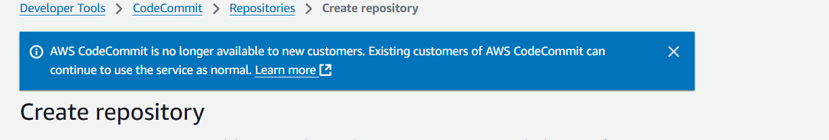

1. Launch an EC2 instance in AWS console.

EC2 > Launch instance > Name – New_app > AMI – amazon linux > instance type – t2.micro > keypair – choose the existing or create new > Network settings – allow http and ssh > launch instance.

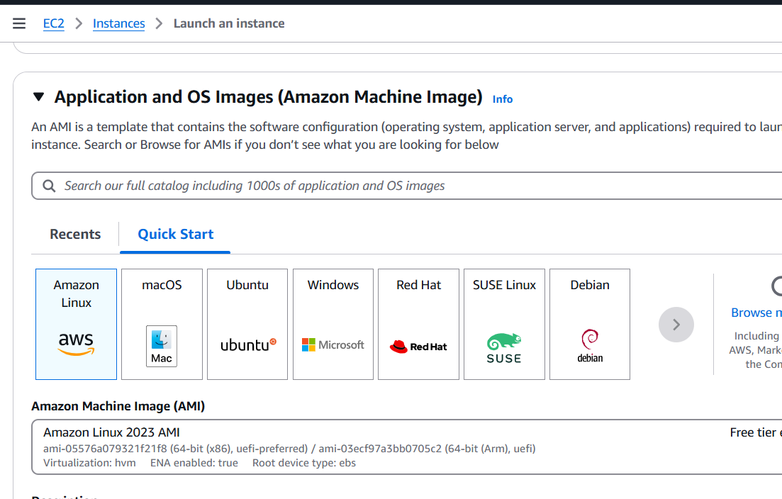

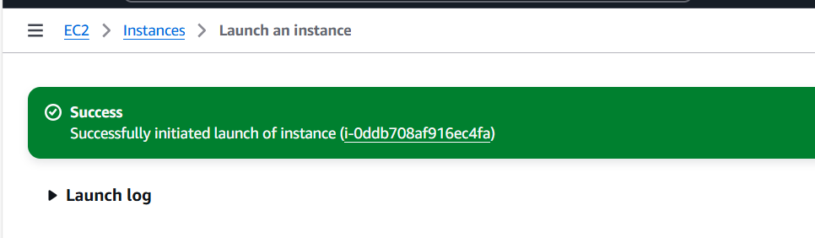

Connect using EC2 instance connect.

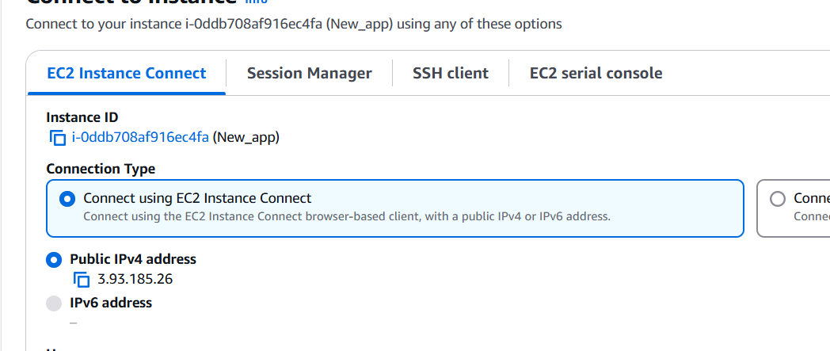

Use the following commands to start the agent for code deploy.

sudo yum update -y

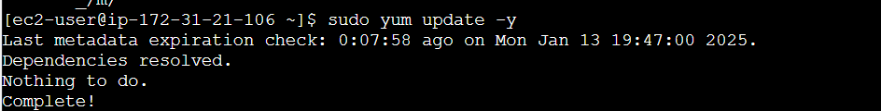

sudo yum install ruby -y

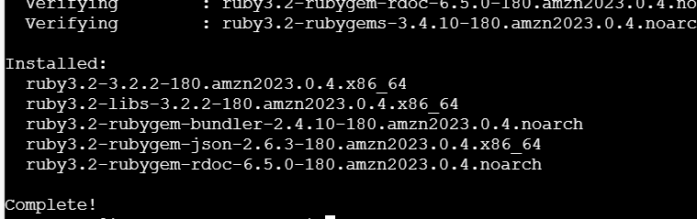

sudo yum install wget -y

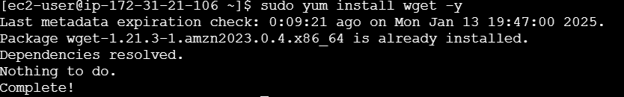

cd /home/ec2-user

wget <https://aws-codedeploy-us-east-1.s3.amazonaws.com/latest/install>

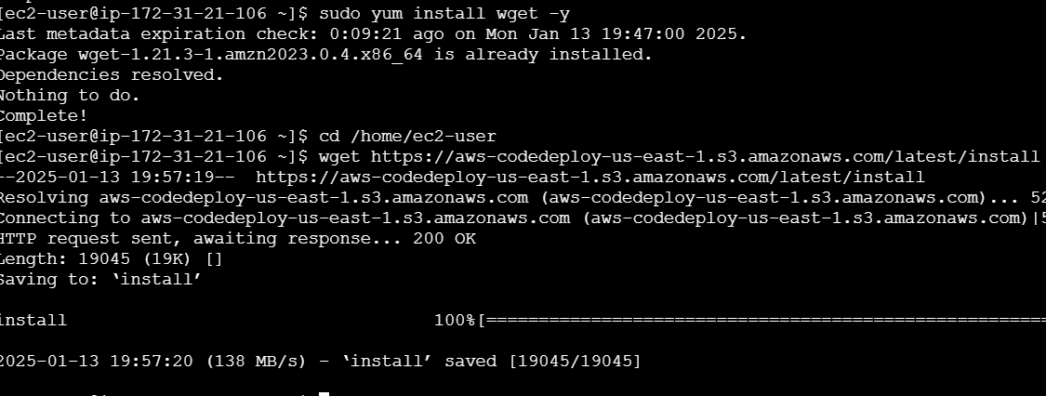

sudo chmod +x ./install

sudo ./install auto

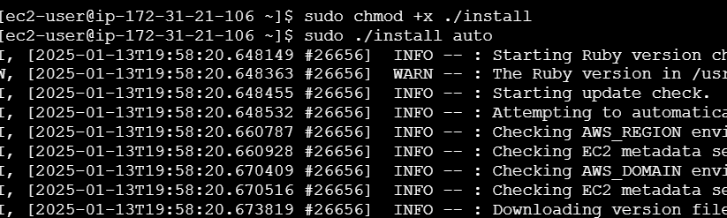

sudo service codedeploy-agent start

sudo service codedeploy-agent status



1. Create new github repo.

Login to github > create new repository

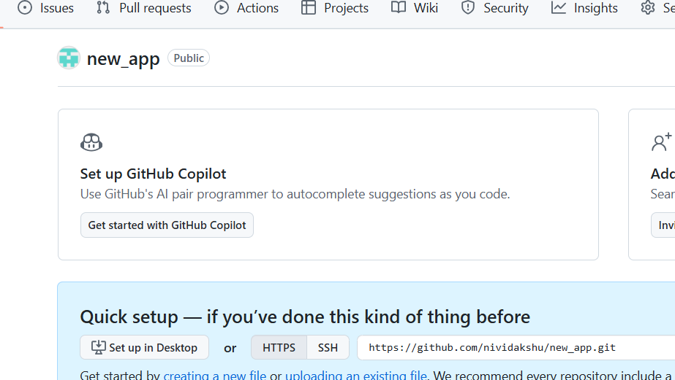

Clone the repository locally.

git clone <https://github.com/nividakshu/new_app.git>



Prepare web application

cd new_app

nano index.html



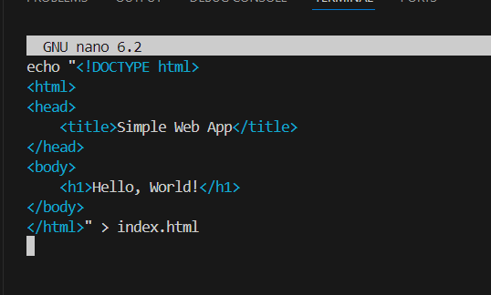

Add deployment scripts - install_dependencies.sh

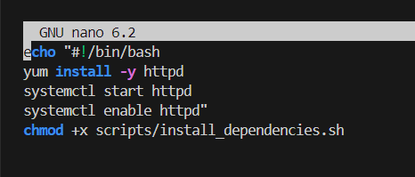

nano appspec.yml

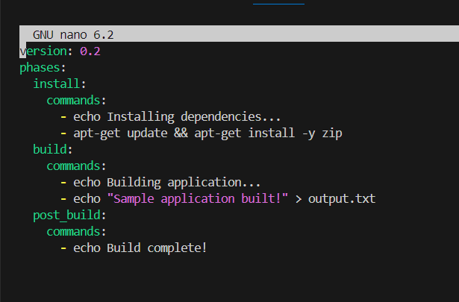

Commit and push to github

git add .

git commit -m "Initial commit with scripts"

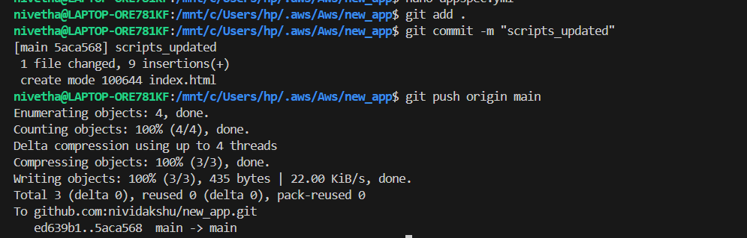

1. Aws code build

Navigate to code build > Build projects > create project> Name - App_project > source – github

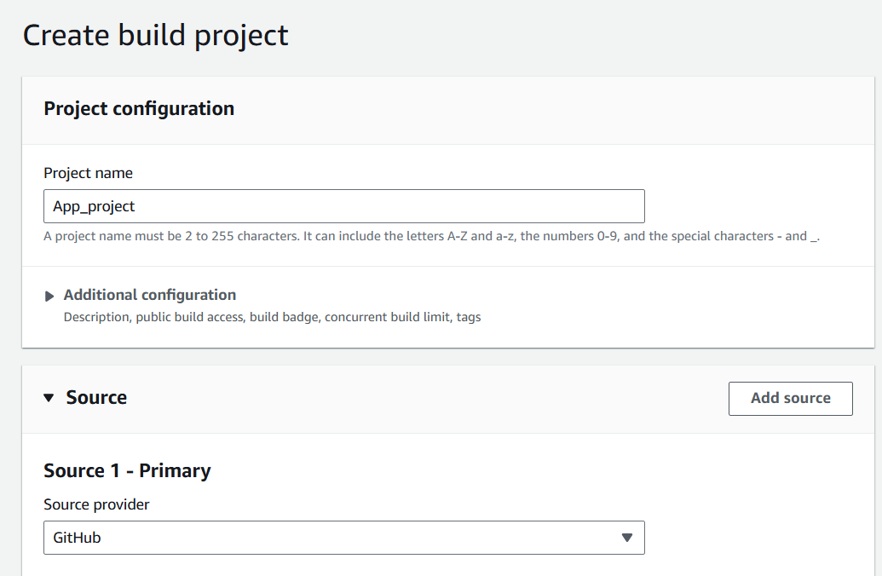

Connect and choose repository

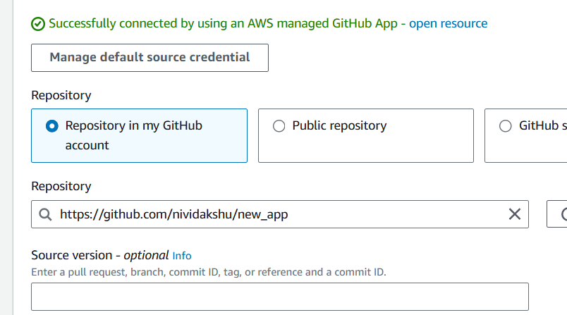

Use a default buildspec file

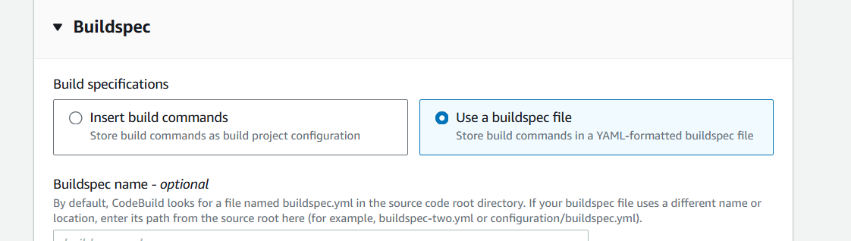

Create build project

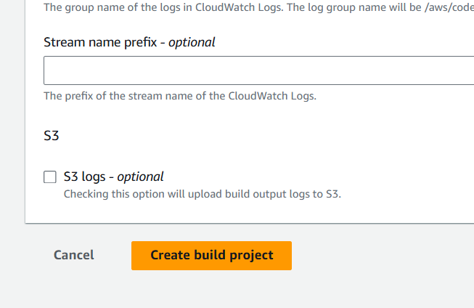

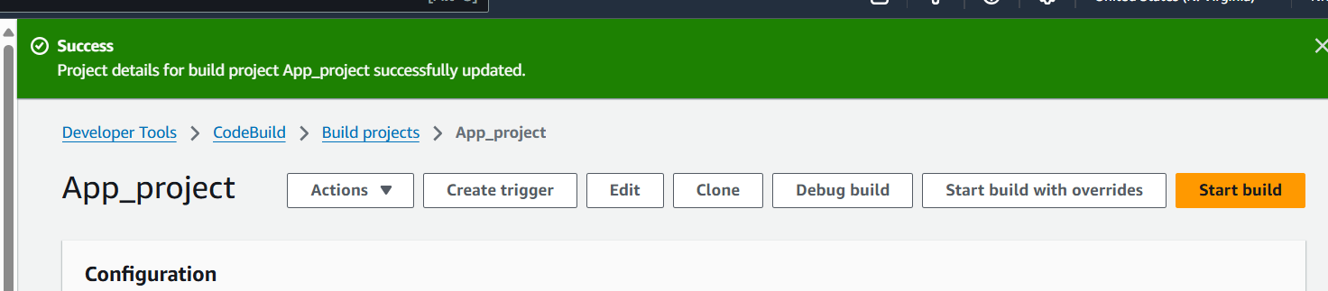

Click start build.

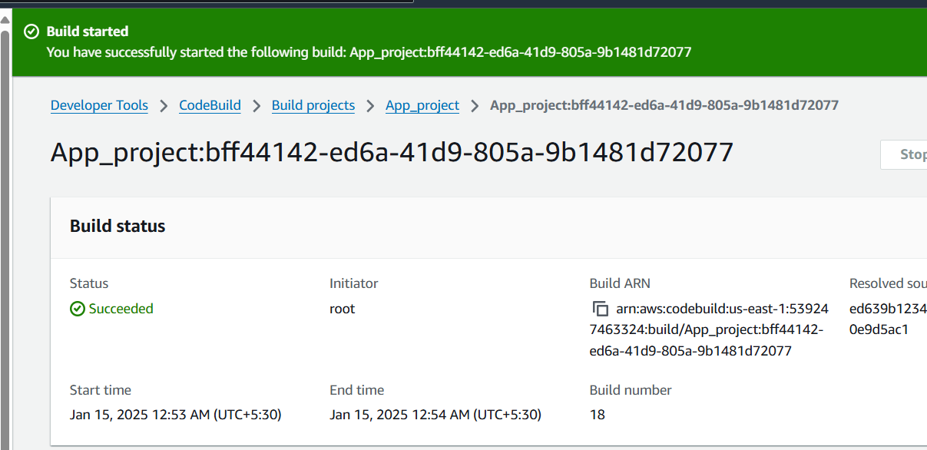

1. Code deploy

Navigate to code deploy > create application > Application name – New app > Compute platform: EC2/On-Premises

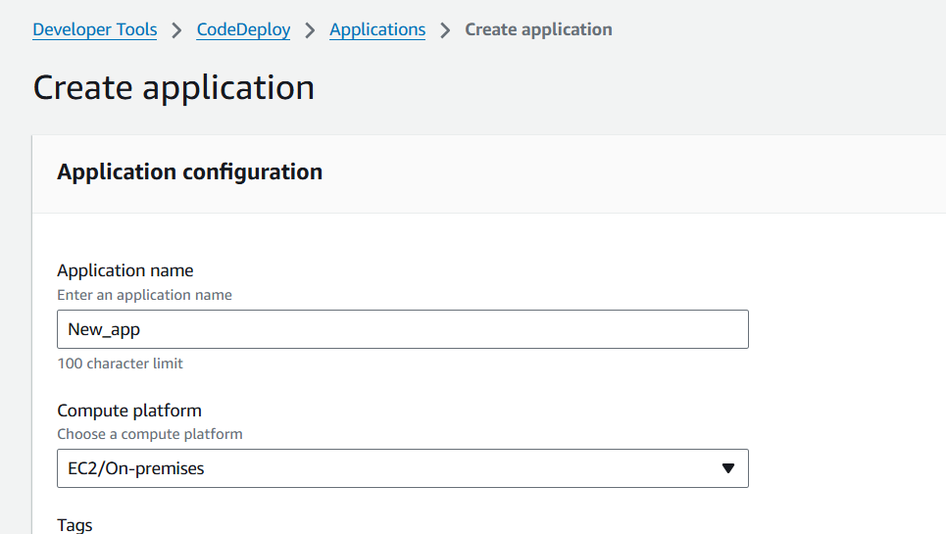

Click create deployment group

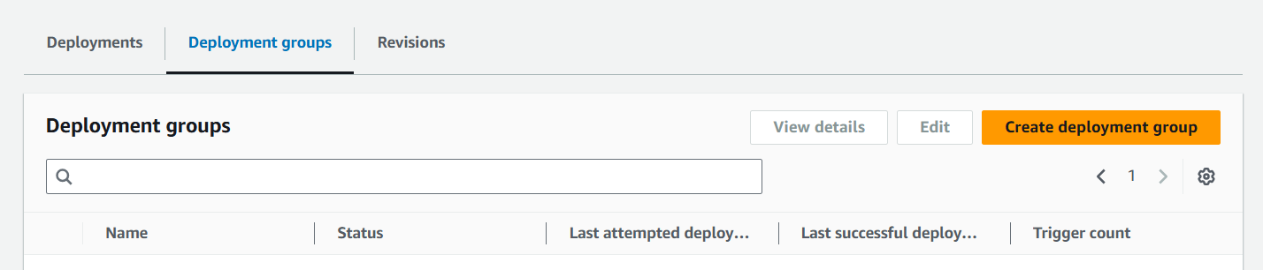

Deployment group - newapp_deployment_group

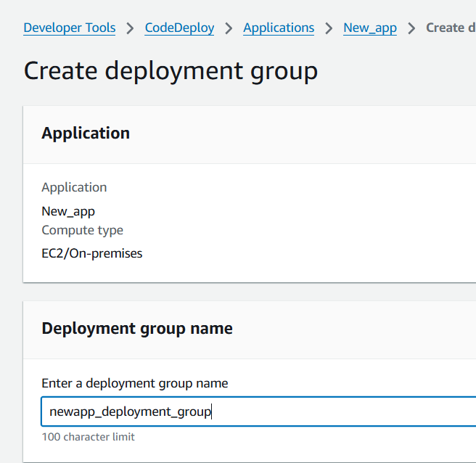

Choose the service role

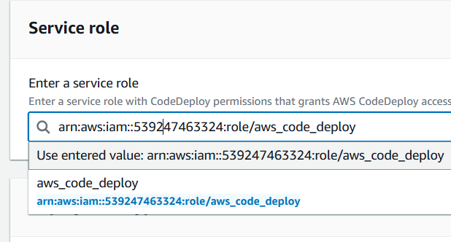

Deployment type – in place

Environment configuration – Amazon EC2 instance

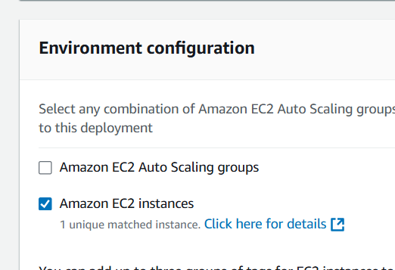

Click create deployment group.

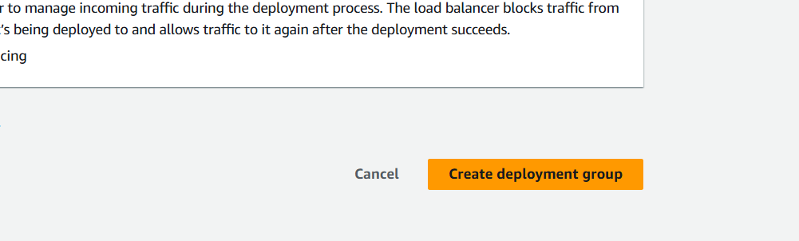

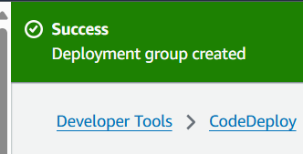

1. AWS Code pipeline

Navigate to code pipeline > create pipeline > build custom pipeline > pipeline name - newapp_pipeline

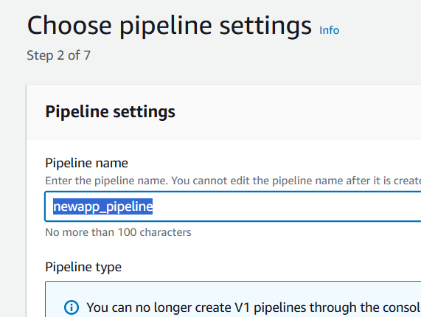

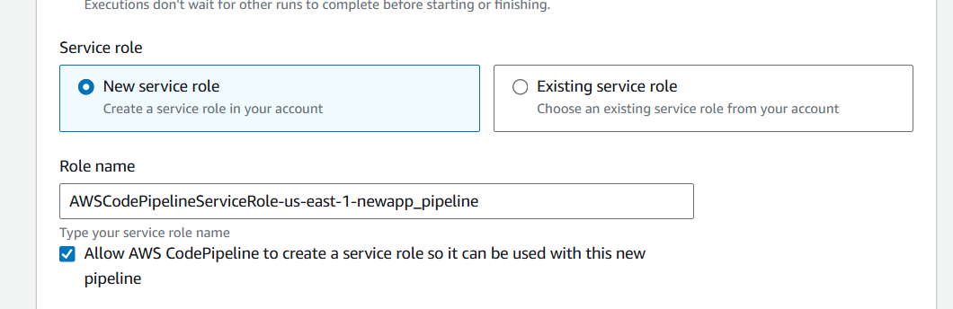

Source – github

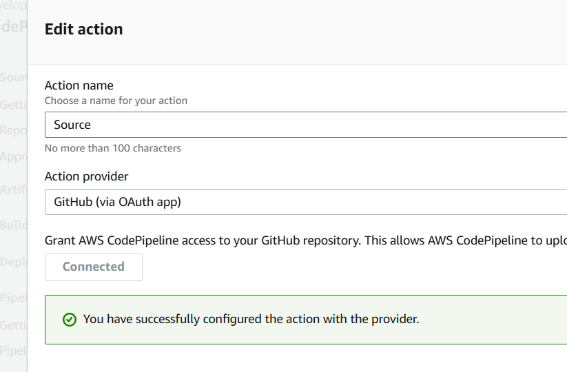

Choose the repo and branch

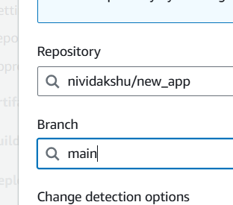

Build > other build providers > AWS code build > select the created project

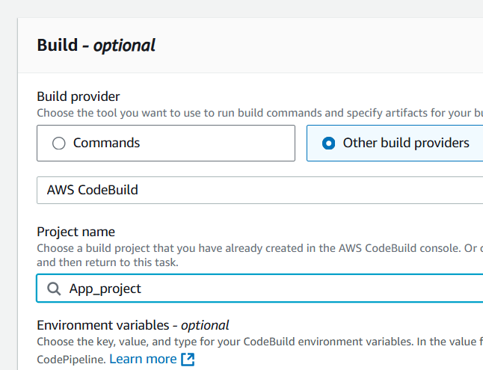

Select AWS code deploy, created application and deployment group.

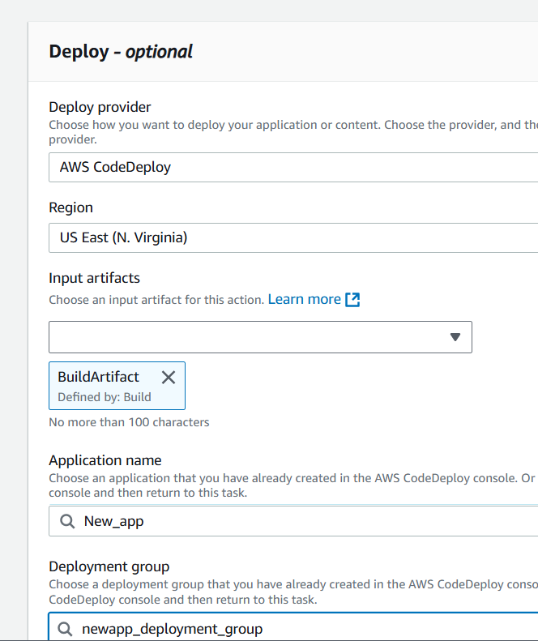

Click create pipeline.

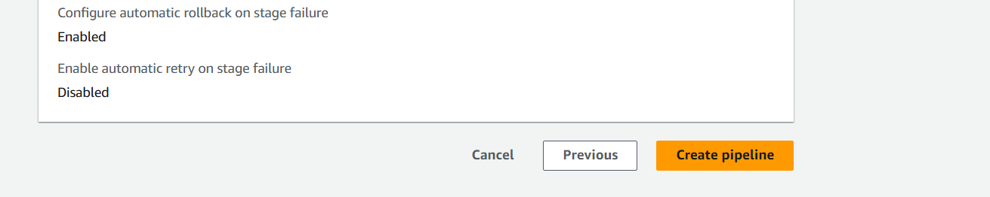

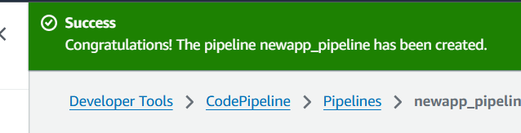

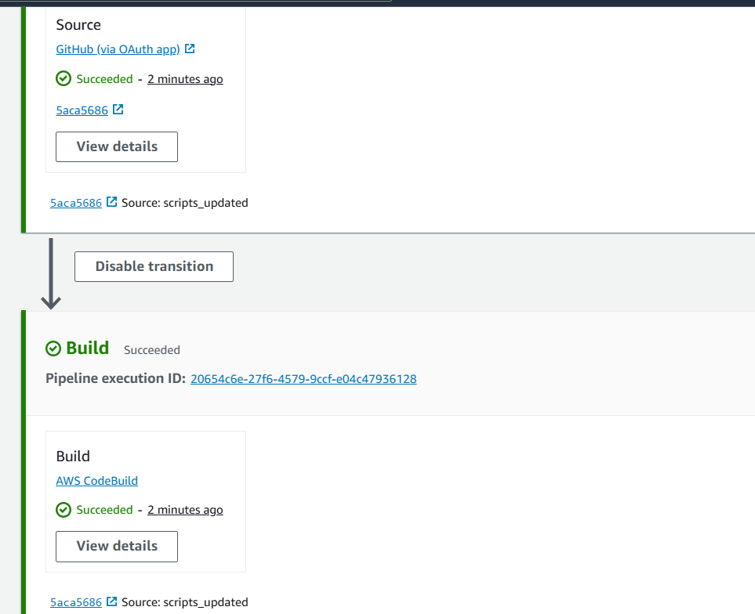

1. Access the webserver using EC2 publc v4 address

